A
Major ProjectReport on

Calmify: Stress and Anxiety Manager

Submitted in partial fulfillment of the requirements for the degree of
BACHELOR OF ENGINEERING
IN

Computer Science & Engineering

Artificial Intelligence & Machine Learning
by
Ananya Dongare:- 23106024
Kimaya Kanyalkar:- 23106007
Arya Ghole:- 23106035
Aparajit Aherkar:- 23106131

Under the guidance of

Prof. Vijaya Jagan



Department of Computer Science & Engineering

(Artificial Intelligence & Machine Learning)
A.P. Shah Institute of Technology
G.B. Road, Kasarvadavali, Thane(W)-400615
University Of Mumbai
2024-2025

CERTIFICATE

This is to certify that the project entitled “Calmify: Stress and Anxiety Manager” is a bonafide work of Ananya Dongare, Arya Ghole, Kimaya Kanyalkar, Aparajit Aherkar submitted to the University of Mumbai in partial fulfillment of the requirement for the award of Bachelor of Engineering in Computer Science & Engineering (Artificial Intelligence & Machine Learning).

______________ | _______________
Prof. Vijaya Jagan | Dr. Jaya Gupta
Mini Project Guide | Head of Department

Project Report Approval

This Mini project report entitled “Calmify: Stress and Anxiety Manager” by Ananya Dongare, Arya Ghole, Kimaya Kanyalkar is approved for the degree of Bachelor of Engineering in Computer Science &Engineering, (AIML)2024-25.

External Examiner:

Internal Examiner:

Place: APSIT, Thane
Date:

Declaration

We declare that this written submission represents my ideas in my own words and where others ideas or words have been included, I have adequately cited and referenced the original sources. I also declare that I have adhered to all principles of academic honesty and integrity and have not misrepresented or fabricated or falsified any idea/data/fact/source in my submission. I understand that any violation of the above willbe cause for disciplinary action by the Institute and can also evoke penal action from the sources which have thus not been properly cited or from whom proper permission has not been taken when needed.

Ananya Dongare | Arya Ghole | Kimaya Kanyalkar | Aparajit Aherkar
(23106024) | (23106035) | (23106007) | (23106031)

ABSTRACT
Stress and anxiety are prevalent challenges in today's fast-paced world, affecting individuals across all demographics. Calmify is an innovative stress and anxiety management solution that integrates mindfulness, cognitive behavioural techniques, and real-time biometric feedback to empower users in their mental well-being journey. By offering personalized recommendations, guided meditation, and interactive self-care tools, Calmify provides a user-centric approach that caters to various levels of expertise. Its AI-driven insights and technological integration enable proactive stress monitoring and intervention, fostering emotional resilience and long-term wellness. Beyond individual benefits, Calmify contributes to workplace productivity and societal well-being by promoting mental health awareness and sustainable stress management practices. Through its holistic approach, Calmify enhances self-awareness, encourages behavioural change, and cultivates a supportive community, making it an essential tool in modern mental health care.

Index

Index |  |  | Page no.
Chapter-1
 | Introduction
Chapter-2
 | Literature Survey
 | 2.1 | History
 | 2.1 | Review
Chapter-3
 | Problem Statement
Chapter-4
 | Experimental Setup
 | 4.1 | Hardware setup
 | 4.2 | Software Setup
Chapter-5
 | Proposed system and Implementation
 | 5.1 | Block Diagram of proposed system
 | 5.2 | Description of Block diagram
 | 5.3 | Implementation
Chapter-6
 | Conclusion
References

CHAPTER 1

INTRODUTION

INTRODUCTION

Calmify – Your Path to a Stress-Free Life
In today’s fast-paced world, stress has become an inevitable part of life. Whether it’s work pressure, personal responsibilities, or societal expectations, managing stress effectively is essential for maintaining overall well-being. Calmify is a dedicated platform designed to help individuals navigate life’s challenges with a calm and balanced approach. It provides practical, science-backed techniques to reduce stress, improve emotional stability, and enhance overall wellness.

Calmify offers a wide range of stress management techniques, ensuring that users can find a method that best suits their needs. One of its core features is guided meditation and mindfulness exercises. These practices help individuals focus on the present moment, reducing anxiety and promoting a sense of peace. Meditation has been scientifically proven to lower cortisol levels, the hormone responsible for stress, while also improving concentration and emotional regulation. Through Calmify, users can access guided sessions tailored to different moods and needs, whether they seek relaxation, clarity, or emotional healing.

Another significant aspect of Calmify is its emphasis on deep breathing techniques. Breathing exercises like diaphragmatic breathing, alternate nostril breathing, and box breathing can significantly reduce stress levels. Controlled breathing helps activate the body’s parasympathetic nervous system, which counteracts the fight-or-flight response triggered by stress. By incorporating these techniques into daily life, users can experience immediate relief from tension and anxiety.

Physical activity plays a crucial role in stress management, and Calmify highlights the importance of yoga and movement-based relaxation. Yoga combines physical postures, controlled breathing, and meditation to enhance both mental and physical well-being. Regular practice helps reduce muscle tension, improve flexibility, and boost mood by increasing endorphin levels. Calmify provides easy-to-follow yoga routines that cater to all experience levels, making relaxation and stress relief
accessible to everyone.

In addition to physical exercises, Calmify encourages the adoption of a healthy lifestyle to maintain emotional balance. Stress often arises from unhealthy habits such as poor sleep, inadequate nutrition, and lack of time management. Calmify offers expert advice
on creating a balanced diet, maintaining proper hydration, and ensuring adequate sleep hygiene. By making small yet impactful lifestyle changes, users can significantly reduce their stress levels and improve overall health. Another powerful tool that Calmify
promotes is journaling and expressive arts therapy. Writing down thoughts and emotions can help individuals process their feelings, gain clarity, and release negative energy. Expressive arts, such as painting, music, or creative writing, serve as therapeutic outlets for self-expression and emotional healing. Calmify provides guidance on how to use these creative techniques to enhance mental well-being and develop resilience against stress.[1]
Furthermore, Calmify recognizes the importance of time management and productivity strategies. Many individuals experience stress due to overwhelming workloads and responsibilities. By offering practical time management techniques, such as prioritization, goal-setting, and structured routines, Calmify helps users create a balanced and efficient lifestyle. Learning to manage time effectively reduces stress and fosters a sense of accomplishment and control.

CHAPTER 2

LITERATURE SURVEY

2.1-LITERATURE SURVEY

- "Managing Anxiety and Stress Holistically: Vedic Wisdom from the Purna Health Management System" by Schulz, Emily K.. 2021.
The study aimed to determine which of key factors correlate with participants' overall stress levels, stress management abilities, and mental/emotional health outcomes. It also sought to identify specific practices within PHMS that are helpful in managing stress and anxiety.

- "Stress and Epilepsy: Towards Understanding of Neurobiological Mechanisms for Better Management" by Jhaveri, D., McGonigal, A., Becker, Christel, Benoliel, J., Nandam, L., Soncin, Lisa-Dounia, Kotwas, I., Bernard, Christopher, and Bartolomei, F.. 2023.
This comprehensive review provides valuable insights into how stress influences epilepsy through various neurobiological pathways and underscores the importance of integrated management approaches to improve outcomes for individuals affected by both conditions.

- "A Systematic Review of Technology-Aided Stress Management Systems: Automatic Measurement, Detection and Control" (Institute of Electrical and Electronics Engineer) by Jimnez-Ocaa, Alvaro A., Pantoja, Andrs, Valderrama, Mario, and Giraldo, Luis Felipe. 2023
Provides a comprehensive analysis of technological tools utilized in stress management, with a particular focus on feedback control systems encompassing detection, control, and intervention phases.

- "Mobile Applications for stress management". by . Anagnostou, M. and Drigas, Athanasios. 2022. Anagnostou and Drigas advocate for the utilization of mobile applications as effective, modern solutions for stress management, complementing traditional methods and providing users with flexible options to address stress in their lives.

2.2-LITERATURE REVIEW

Research Paper | Summary | Key Factors
“Managing Anxiety and Stress Holistically: Vedic Wisdom from the Purna Health Management System” | Determine which of four key factors correlate with participants' overall stress levels, stress management abilities, and mental/emotional health outcomes. | 1.Health, Fitness, and Nutrition (HF&N)  2.Life Balance  3.Spiritual Growth and Development (SG&D)  4.Living in Harmony with the Natural Environment to Support Health (LHWNE):
"Stress and Epilepsy: Towards Understanding of Neurobiological Mechanisms for Better Management” | Explains importance of integrated management approaches to improve outcomes for individuals affected by both conditions. | 1.Impact of Stress on Epilepsy  2.Neurobiological Mechanisms
"A Systematic Review of Technology-Aided Stress Management  Systems: Automatic Measurement, Detection and Control" | Provides a comprehensive analysis of technological  tools utilized in stress management, with a particular focus on feedback  control systems encompassing detection, control, and intervention phases. | - Physiological Variables  - Intervention Techniques  - Feedback Control System
"Mobile Applications for stress management". | The authors highlight that traditional methods for stress reduction include counseling, training, and exercise. However, with technological advancements, mobile applications have emerged as innovative tools for stress management. | 1.Accessibility and Convenience  2.Diverse Techniques  3.Personalization

CHAPTER 3

PROBLEM STATEMENT

3.PROBLEM STATEMENT

In today’s fast-paced world, stress and anxiety have become prevalent issues affecting people of all ages. The constant pressure from work, academics, personal responsibilities, and social expectations leads to mental exhaustion, burnout, and decreased overall well-being. Many individuals struggle to manage their stress effectively due to a lack of awareness, time, or access to reliable mental health resources.
Traditional stress management solutions often focus on medical interventions or expensive therapy sessions, which may not be accessible to everyone. Moreover, the stigma surrounding mental health prevents many from seeking professional help. As a result, people continue to suffer from stress-related issues such as insomnia, irritability, decreased productivity, and even long-term health complications like hypertension and heart disease.[2]
Calmify aims to bridge this gap by providing an easily accessible, holistic, and science-backed platform for stress management. It offers guided meditation, breathing exercises, yoga, journaling, and lifestyle improvement techniques that empower individuals to take control of their mental well-being. By integrating simple yet effective stress-relief practices into daily life, Calmify helps users develop long-term resilience and achieve a balanced, healthier lifestyle without the need for medical intervention or costly therapy sessions.

The challenge lies in designing a solution that is:
- Personalized – Tailoring stress management strategies based on individual triggers and preferences.
- Accessible – Ensuring ease of use for users with different technological expertise.
- Effective – Providing scientifically backed techniques that yield measurable improvements.
- Engaging – Encouraging consistent use through interactive and motivating features.

CHAPTER 4

EXPERIMENTAL SETUP

4. Experimental Setup

Objective:
The objective of this study is to evaluate the effectiveness of the Sukoon Stress-Free platform in reducing stress and improving mental well-being among users. The experiment aims to assess user engagement, stress levels before and after platform usage, and the impact of different platform features

- Platform Development:
The Sukoon Stress-Free platform is a web-based application developed using modern front-end technologies for user data management. The platform includes interactive stress-relief techniques, guided meditation, breathing exercises for users.

Participants:

Demographics: Adults aged 18–25

Selection Criteria:
  - Individuals experiencing moderate stress levels.
  - Participants with no prior experience using stress management applications.
  - Willingness to participate for their well being..

Expected Outcome:
Significant reduction in stress levels among participants using the Sukoon Stress-Free platform.
Positive user engagement and feedback indicating ease of use and effectiveness of stress-relief techniques.
Data-driven insights on which features contribute most to stress reduction.
Potential recommendations for further development and improvements to enhance the platform’s effectiveness.

CHAPTER 5

PROPOSED SYSTEM & IMPLEMENTATION

Proposed system & Implementation

5.1 Block diagram of proposed system

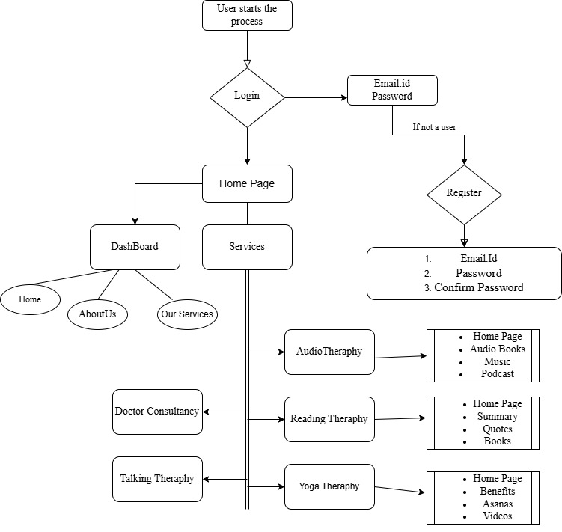

Fig 5.1: Block Diagram

Description of block diagram

Home Page (index.html):

Welcome message with navigation bar

User Authentication
    - Register (login.html):
If the user is not registered, they must create an account by providing:
Email ID, Password, Confirm Password
Basic form to create an account with email and password.
    - Login (login.html)
Users enter credentials to log in. After successful login, the user is redirected to the Home
Page

  - Home Page Navigation
From the home page, the user has two primary navigation options:
Dashboard
Contains links to:
- Home
- About Us
- Our Services
Services
Provides access to various stress management therapies.

Stress Management Services
The platform offers different therapy services:
Audio Therapy
Includes:
Audio Books , Music , Podcasts
Reading Therapy
Offers:
Summaries , Quotes , Books
Yoga Therapy
Provides:
Benefits of yoga , Asanas (yoga postures) , Videos for guidance
Talking Therapy
Allows users to engage in stress-relief conversations with professionals or support groups.
Doctor Consultancy
Users can consult doctors for stress-related issues.

5.3 Implementation

Implementation of proposed system

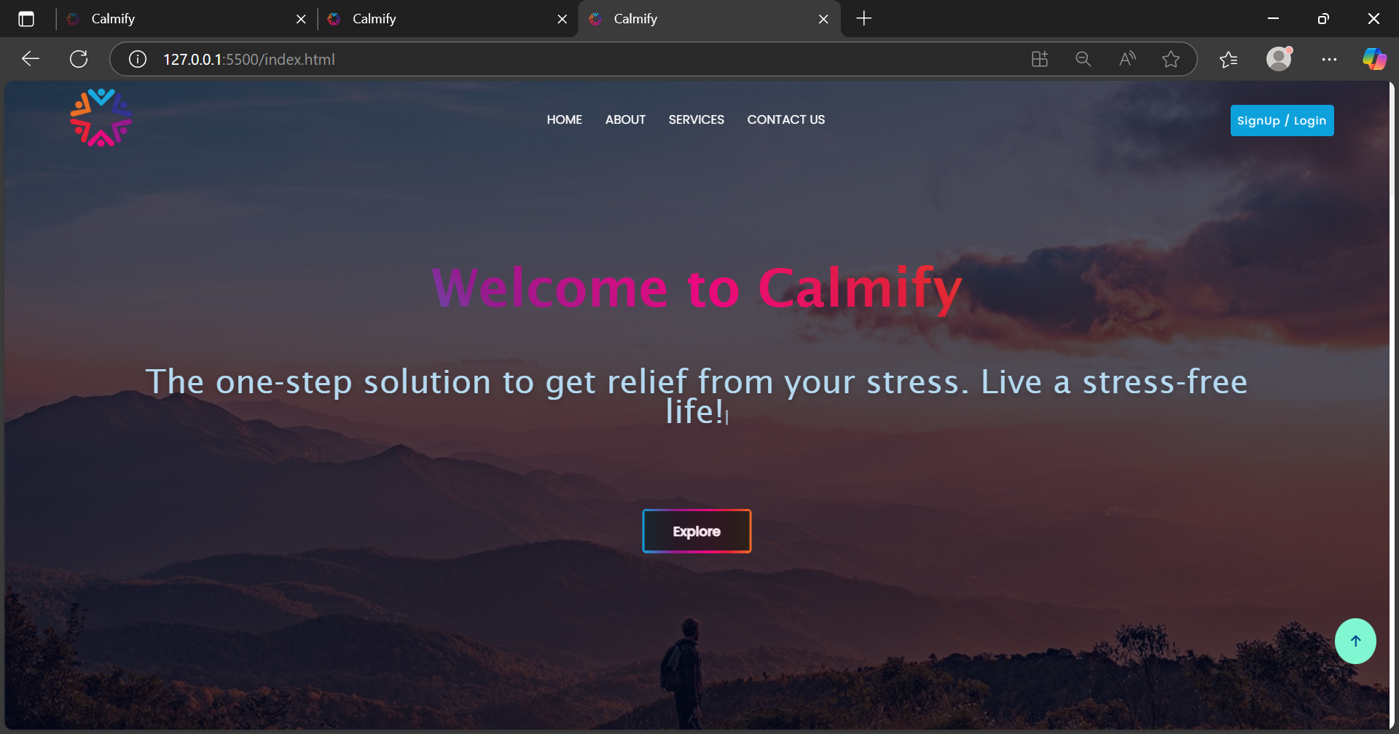

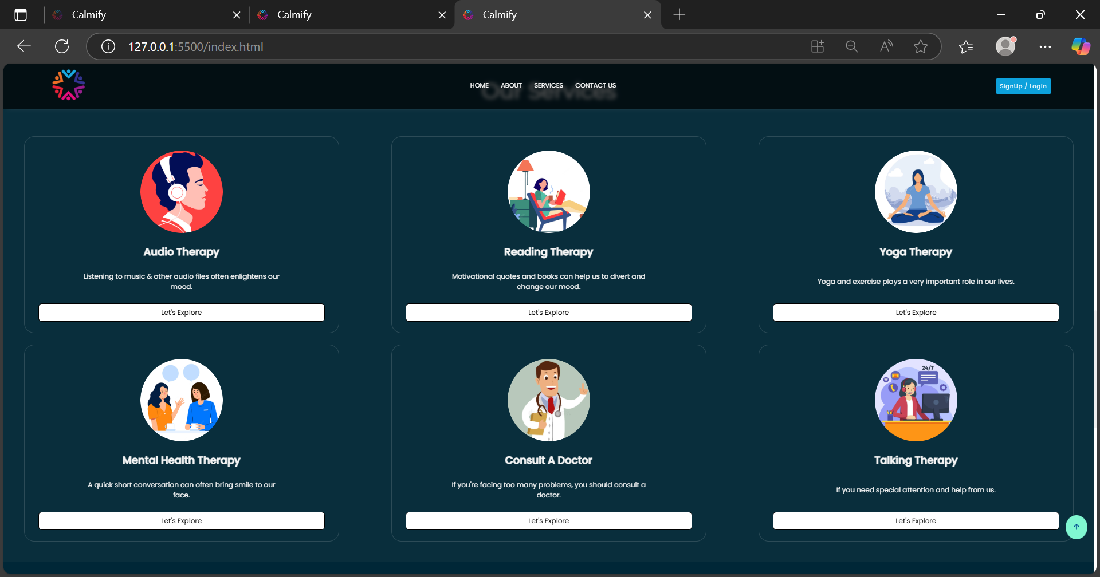

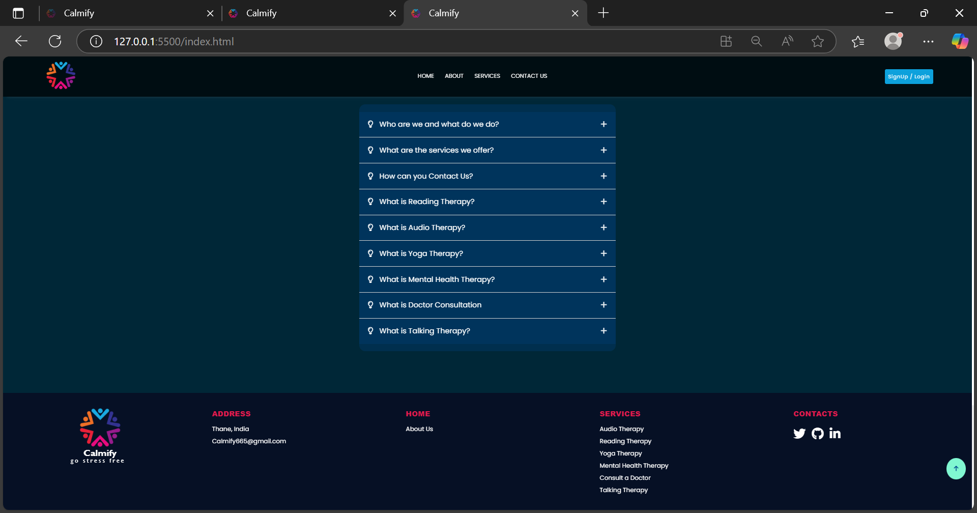

Fig: 5.3.1 :Home Screen

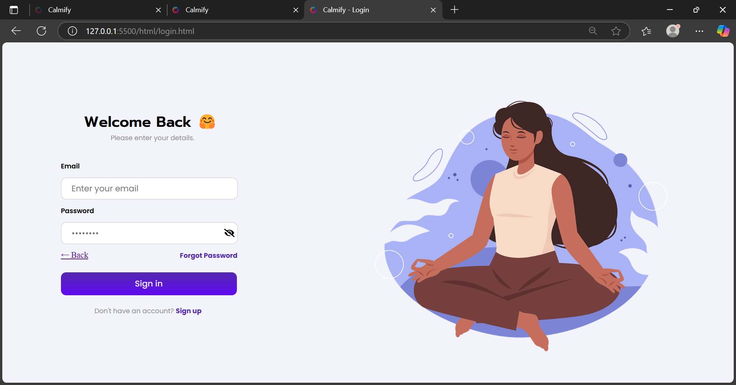

Fig 5.3.2: Login Page

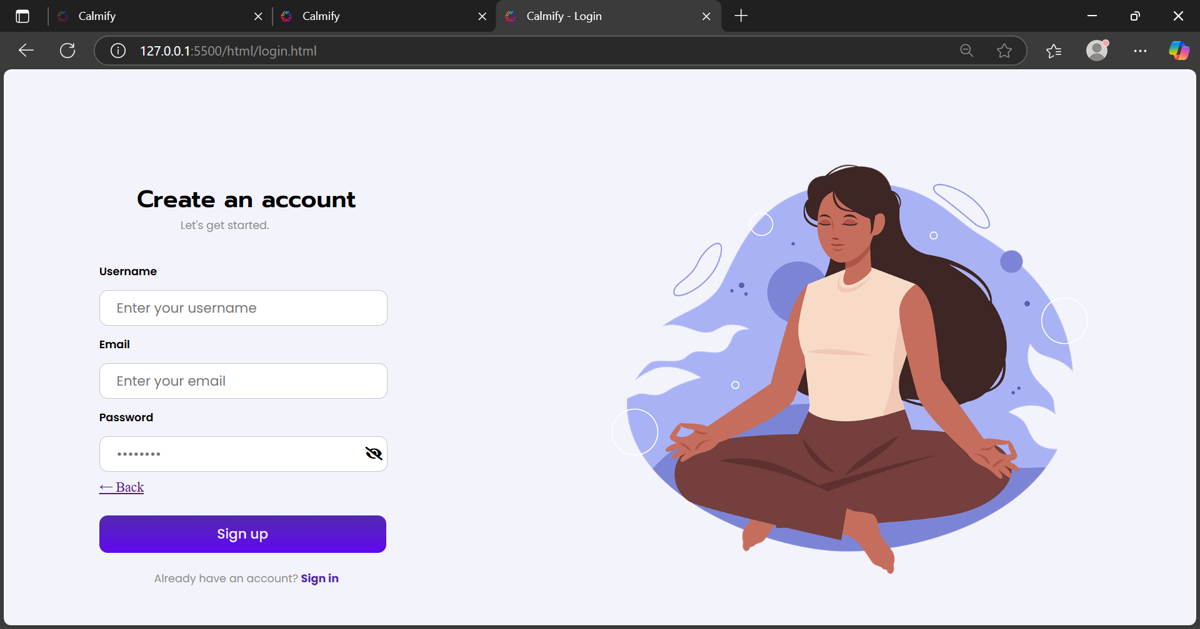

Fig 5.3.3: Signup Page

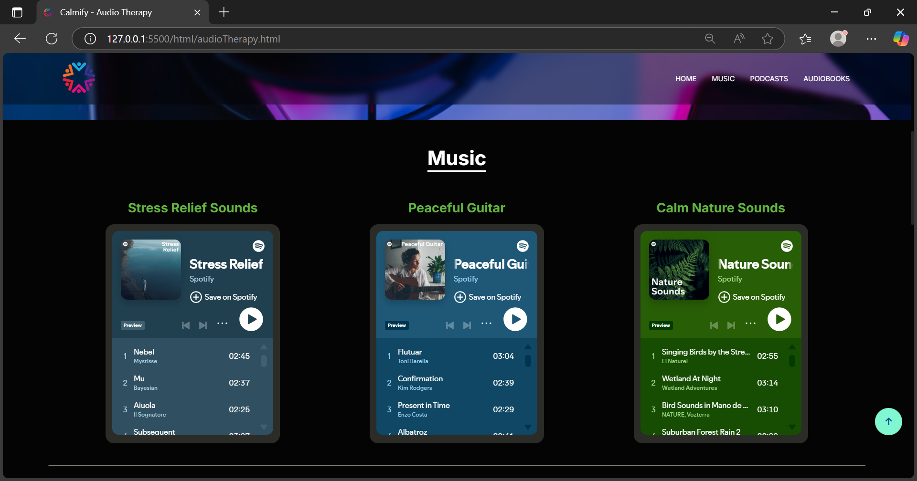

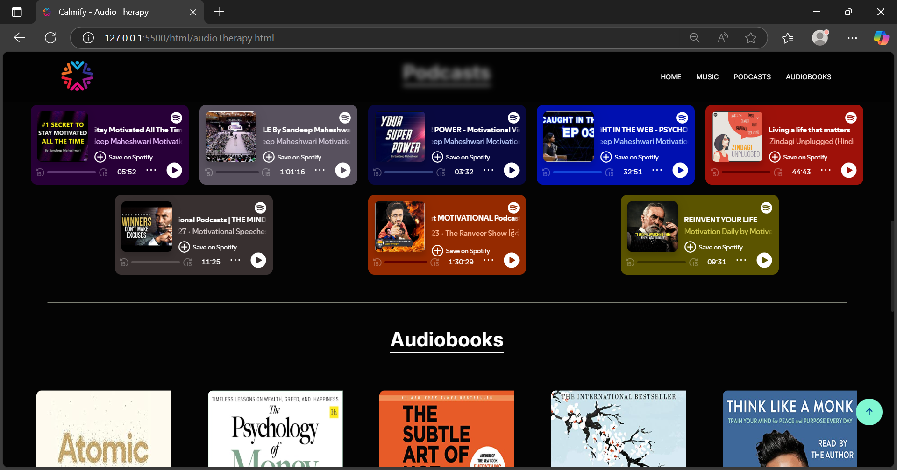

Fig 5.3.4: Audio Therapy

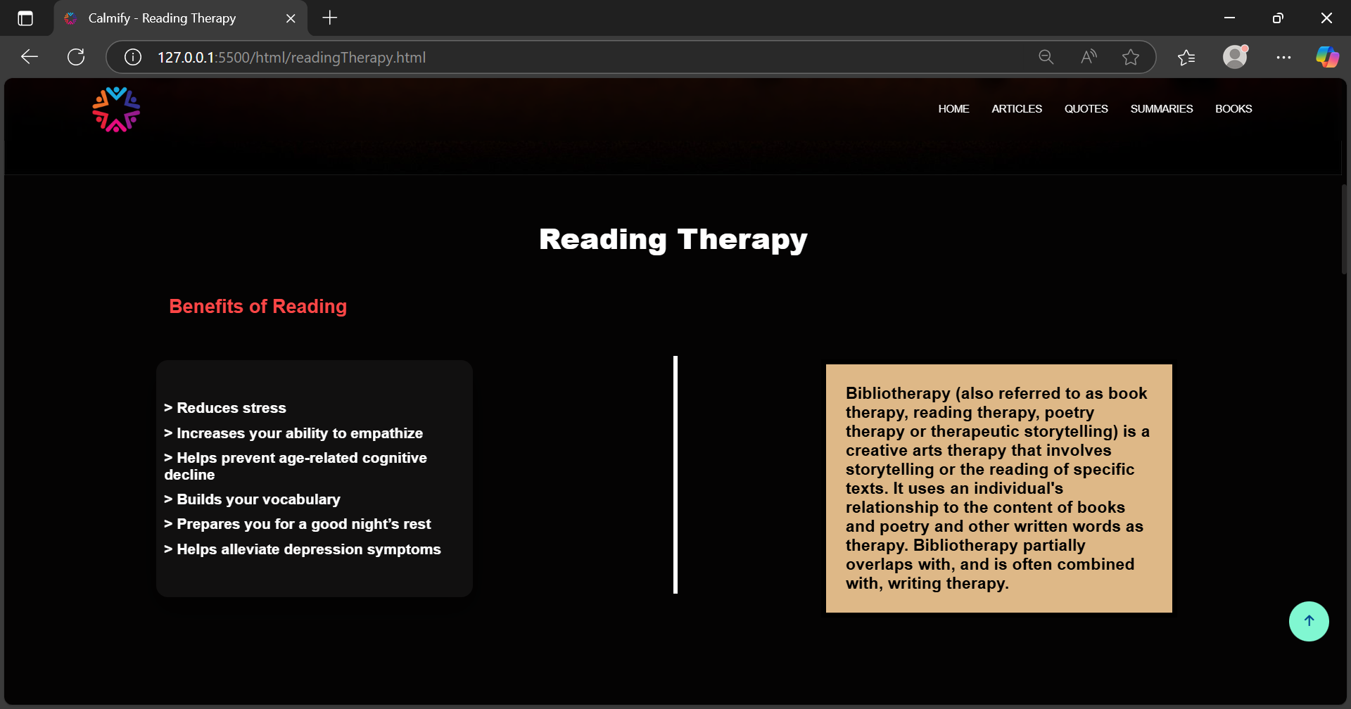

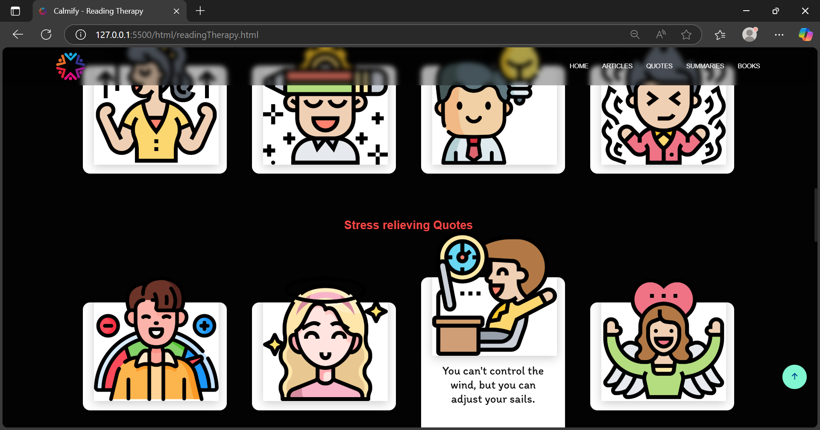

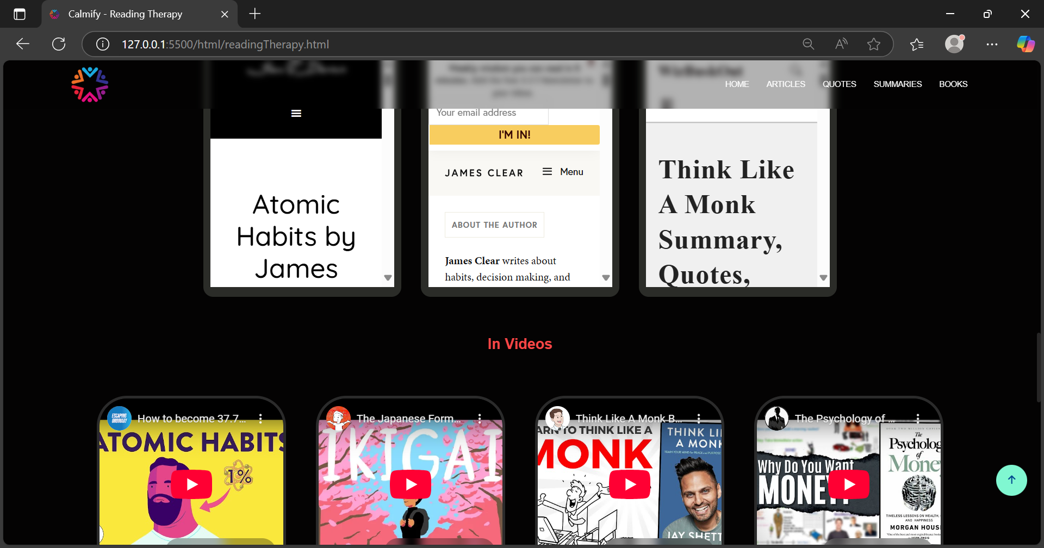

Fig 5.3.5: Reading Therapy

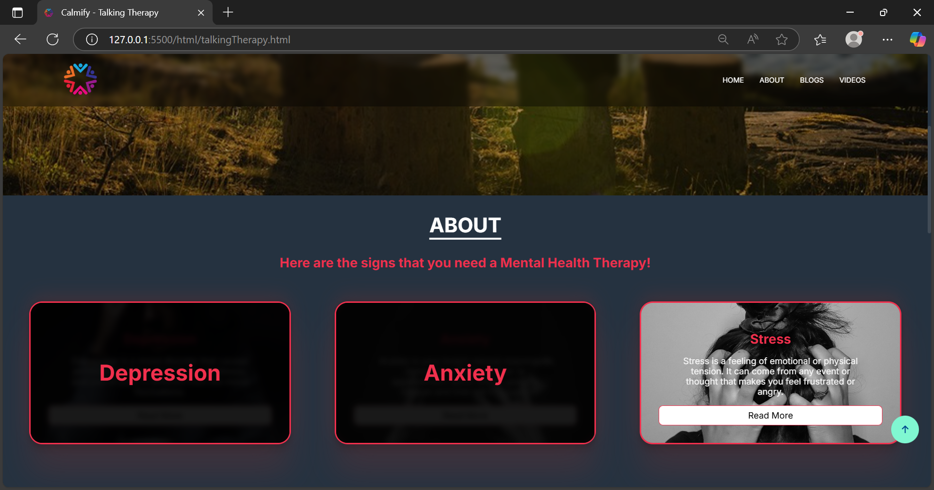

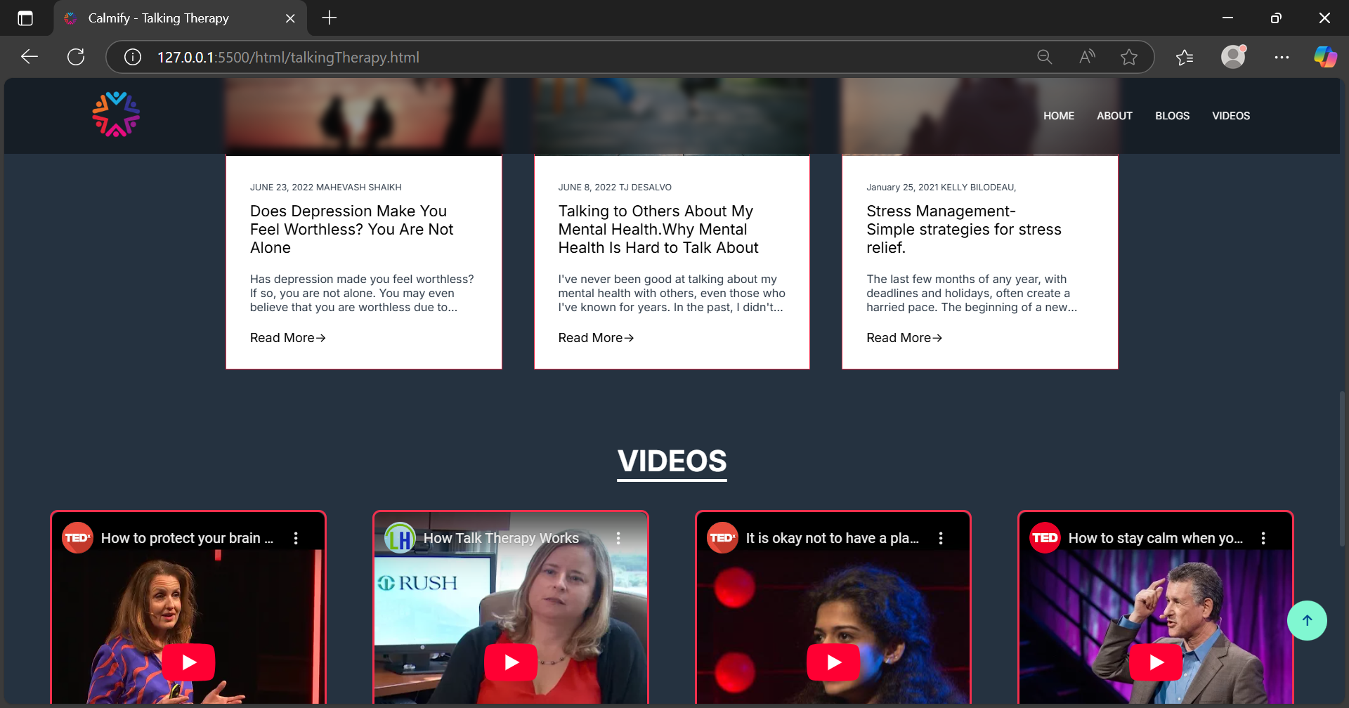

Fig 5.3.6: Mental health Therapy

CHAPTER 6

CONCLUSION

Conclusion
Calmify emerges as a revolutionary solution, offering a holistic approach to stress and anxiety management through scientifically-backed techniques and innovative technology. By combining mindfulness practices, guided meditation, cognitive behavioral strategies, and real-time stress monitoring, empowers users to take charge of their mental well-being effectively and conveniently. Calmify has the potential to contribute to workplace productivity and overall societal well-being. As stress and anxiety significantly impact employee performance, organizations that implement Calmify as part of their wellness programs can expect improved engagement, increased job satisfaction, and reduced burnout among their workforce. By fostering a culture of mental well-being, businesses can create healthier, more supportive work environments that enhance both individual and collective success.[3]
In conclusion, Calmify represents a significant advancement in the field of stress and anxiety management, offering a comprehensive, accessible, and effective solution to individuals seeking relief from daily pressures. By leveraging cutting-edge technology, evidence-based techniques, and a user-friendly interface, Calmify empowers users to cultivate a healthier mind and a more balanced life. As stress and anxiety continue to be pressing concerns, tools like Calmify serve as essential resources in fostering mental well-being and enhancing overall quality of life.

References

- Schulz, Emily K.. 2021. "Managing Anxiety and Stress Holistically: Vedic Wisdom from the Purna Health Management System". Journal of Anxiety & Depression.

- Jhaveri, D., McGonigal, A., Becker, Christel, Benoliel, J., Nandam, L., Soncin, Lisa-Dounia, Kotwas, I., Bernard, Christopher, and Bartolomei, F.. 2023. "Stress and Epilepsy: Towards Understanding of Neurobiological Mechanisms for Better Management".

- Jimnez-Ocaa, Alvaro A., Pantoja, Andrs, Valderrama, Mario, and Giraldo, Luis Felipe. 2023. "A Systematic Review of Technology-Aided Stress Management Systems: Automatic Measurement, Detection and Control". Institute of Electrical and Electronics Engineers.

- Anagnostou, M. and Drigas, Athanasios. 2022. "Mobile Applications for stress management". Federal University of Mato Grosso.

- Børøsund, Elin, Varsi, Cecilie, Clark, Matthew M, Ehlers, Shawna L, Andrykowski, Michael A, Sleveland, Hilde Renate Sætre, Bergland, Anne, and Nes, Lise Solberg. 2019. "Pilot testing an app-based stress management intervention for cancer survivors". Translational Behavioral Medicine.

